**EXPERIMENT NO. 11**

**AIM** : Practical implementation of basic network command and Network configuration commands like ping, ipconfig, netstat, tracert etc. for troubleshooting network related problems

**MATERIAL:** Command Prompt And Packet Tracer

**PROCEDURE**: To do this EXPERIMENT-follows these steps: In this EXPERIMENT-students have to understand basic networking commands e.g ping, tracert etc.

All commands related to Network configuration which includes how to switch to privilege mode and normal mode and how to configure router interface and how to save this configuration to flash memory or permanent memory.

This commands includes

* Configuring the Router commands
* General Commands to configure network
* Privileged Mode commands of a router
* Router Processes & Statistics
* IP Commands
* Other IP Commands e.g. show ip route etc.
* **IPCONFIG:**

The IPCONFIG network command provides a comprehensive view of information regarding the [IP address](https://www.simplilearn.com/tutorials/cyber-security-tutorial/what-is-an-ip-address) configuration of the device we are currently working on.

The IPConfig command also provides us with some variation in the primary command that targets specific system settings or data, which are:

* IPConfig/all - Provides primary output with additional information about network adapters.
* IPConfig/renew - Used to renew the system’s IP address.

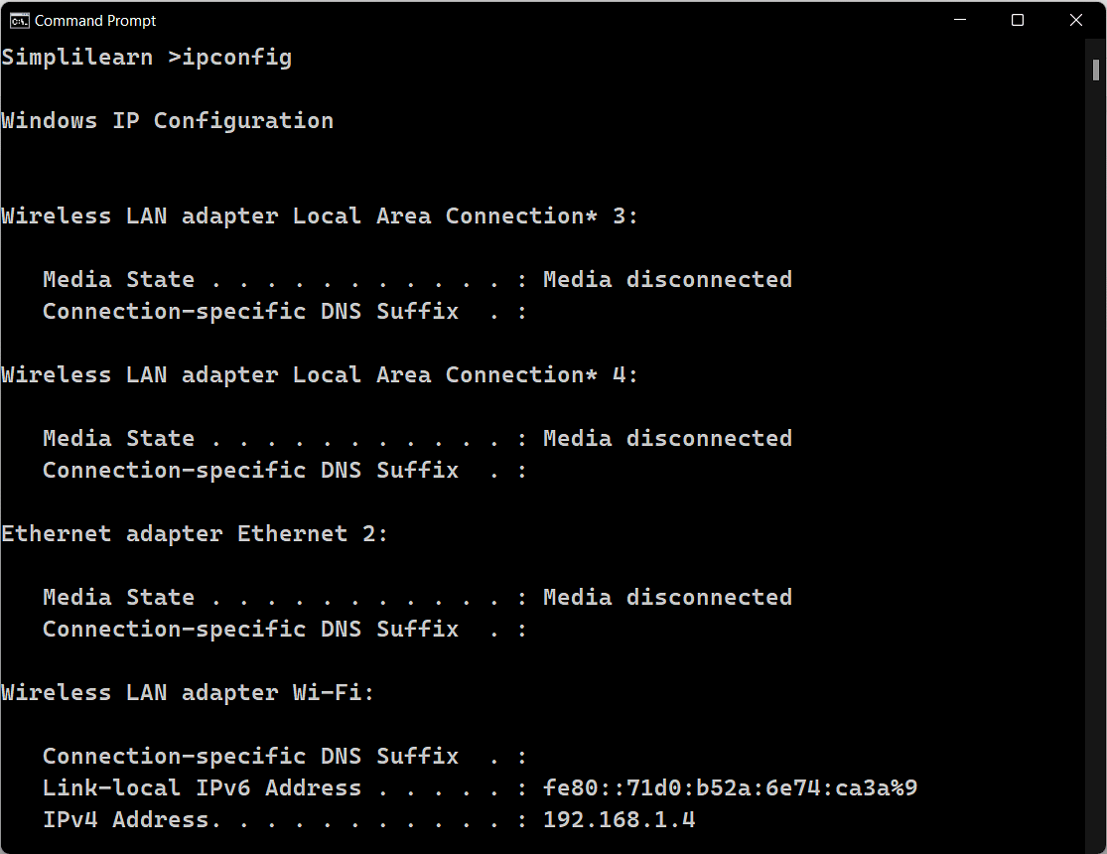

* **NSLOOKUP**

The NSLOOKUP command is used to troubleshoot network connectivity issues in the system. Using the nslookup command, we can access the information related to our system’s DNS server, i.e., domain name and IP address.

Command to enter in Prompt - nslookup

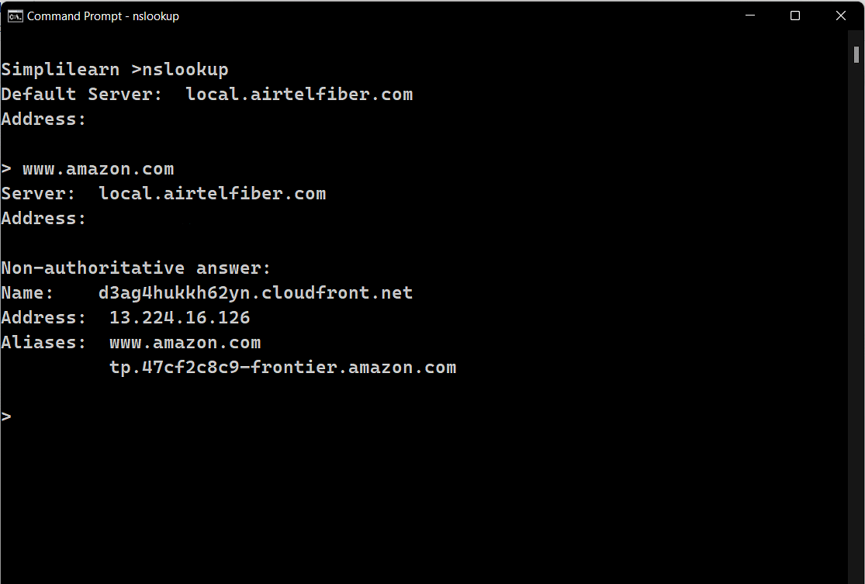

* **HOSTNAME**

The HOSTNAME command displays the hostname of the system. The hostname command is much easier to use than going into the system settings to search for it.

Command to enter in Prompt - hostname

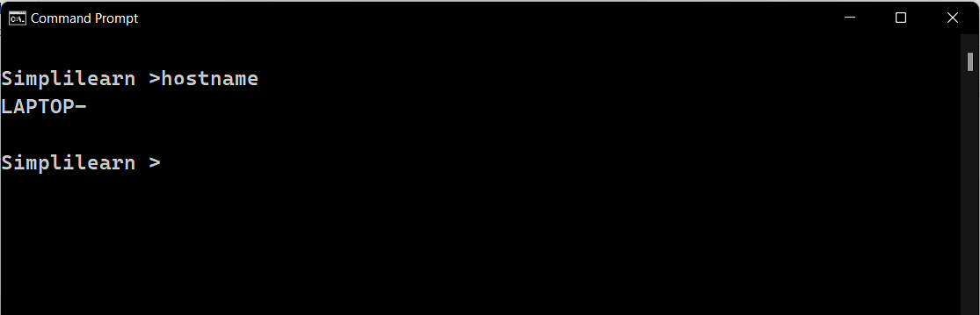

The HOSTNAME command displays the hostname of the system. The hostname command is much easier to use than going into the system settings to search for it.

Command to enter in Prompt – hostname

* **PING**

The Ping command is one of the most widely used commands in the prompt tool, as it allows the user to check the connectivity of our system to another host.

This command sends four experimental packets to the destination host to check whether it receives them successfully, if so, then, we can communicate with the destination host. But in case the packets have not been received, that means, no communication can be established with the destination host.

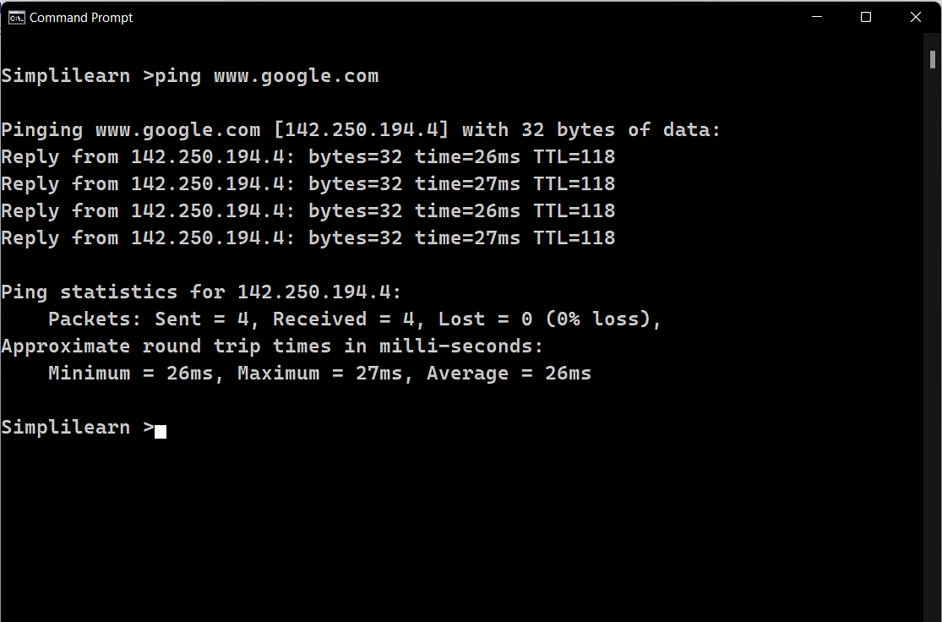

* **TRACERT**

The TRACERT command is used to trace the route during the transmission of the data packet over to the destination host and also provides us with the “hop” count during transmission.

Using the number of hops and the hop IP address, we can troubleshoot network issues and identify the point of the problem during the transmission of the data packet.

Command to enter in Prompt- tracert IP-address OR tracert [www.destination_host_name.com](http://www.destination_host_name.com)

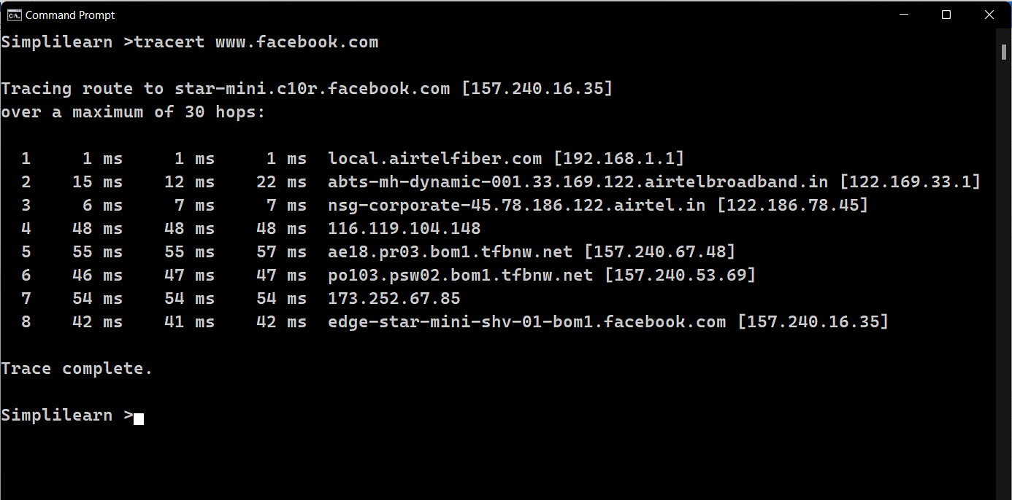

* **NETSTAT**

The Netstat command as the name suggests displays an overview of all the network connections in the device. The table shows detail about the connection protocol, address, and the current state of the network.

Command to enter in Prompt – netstat

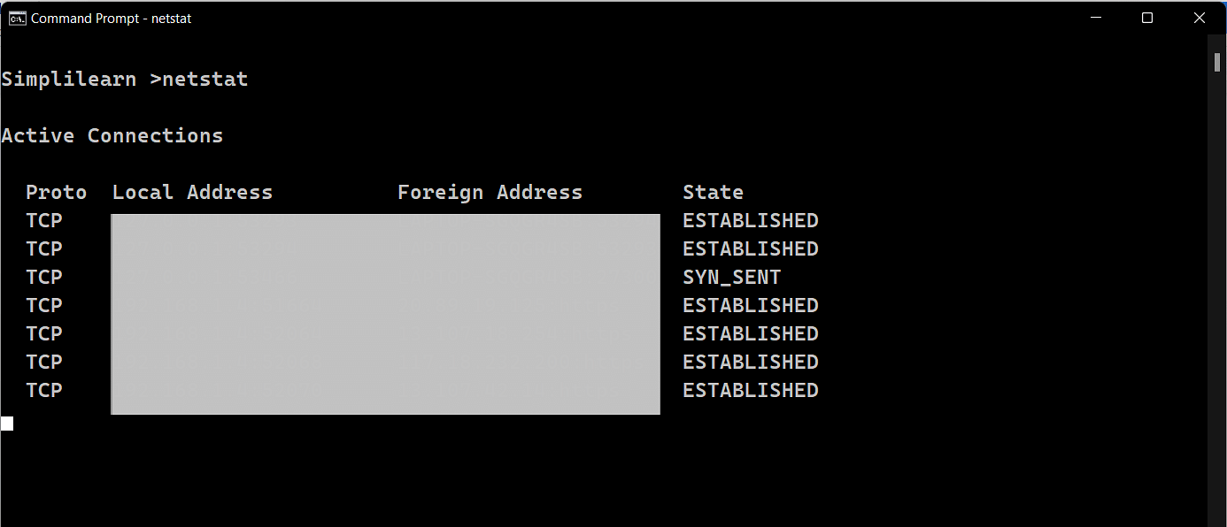

* **ARP(Address Resolution Protocol)**

The ARP command is used to access the mapping structure of IP addresses to the MAC address. This provides us with a better understanding of the transmission of packets in the network channel.

Command to enter in Prompt - arp

